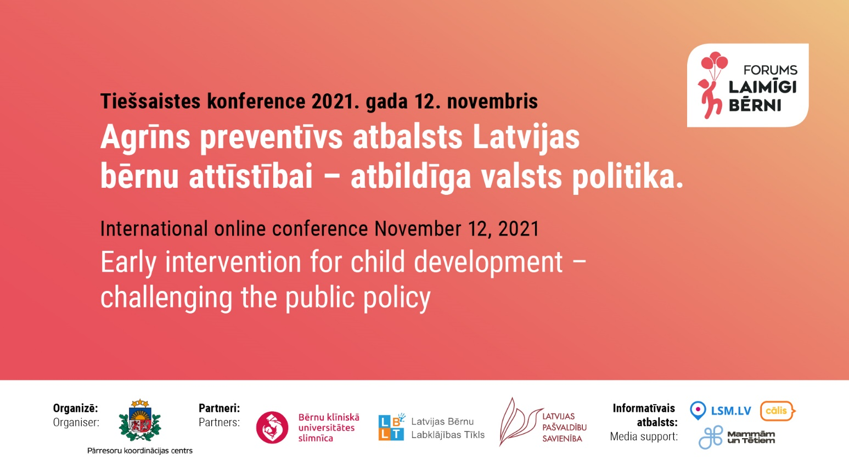

Latvian Forum for Child Happiness

International Conference:
Early intervention for child development – challenging the public policy

Organiser: Cross-Sectoral Coordination Centre in cooperation with partners
Partners: Latvian Association of Local and Regional Governments, Latvian Child Welfare Network, Children’s Clinical University Hospital

Media support: LSM.lv, Delfi.lv

The first international Forum for Child Happiness is dedicated to achieving consensus on the establishment of a unified early childhood intervention system (ECI) for balanced child development in Latvia.
While there is sufficient evidence that a lack of coherence in prevention and early childhood interventions in Latvia requires immediate attention, there has been little consensus in the country on the way forward. Sectoral interests, traditional administrative approaches, lack of experience in coordinating interventions have resulted in administrative and political deadlock.
This conference brings together parents, practitioners, teachers, psychologists, medical experts, politicians, persons with public administration and sectoral policy experience having diverse views concerning system development - with the aim of achieving agreement on a solution that benefits the child.
Experts from several countries will share best practice, knowledge and advice on establishing evidence based early childhood intervention systems and implementing methods and programmes. A summary of conclusions afforded by the comparative approach will be followed by a discussion on the next steps in of planning and organising the early preventive intervention system in Latvia.
Agenda

9:00 – 9:30 | Opening  No “business as usual”: why unify early intervention services for child development in Latvia  Pēteris VILKS, Head of the Cross-Sectoral Coordination Centre  Addresses by honorary guests

9:30 – 12:30 | Part I  Establishing child development intervention systems – perspectives from abroad
09:30-09:50 | International practice and solutions for the establishment of an early childhood preventive intervention system in Latvia  Research results obtained from analyzing high quality and cost-effective models from Europe and around the world – establishment, implementation and assessment, and drawing lines with current Latvian approach to supporting children and their families.  Ieva SKUBIŅA, Dr.sc.soc. is a consultant actively involved in child and family policy planning and assessment since 2000; she has conducted research on comparative approaches in coordinating public services specifically for this Forum.  Q&A
09:55-10:25 | The Science of Early Childhood Intervention in 2021: Research, Models and Practices  What we know about early childhood intervention (ECI) has evolved over the last 50 years. Ongoing research has identified models and practices – key elements of an effective system of ECI - that lead to strong and positive outcomes for children, their families, and their communities. Significant paradigm shifts have taken place as we have learned more about “what matters most.”  Marilyn ESPE – SHERWINDT, PhD, is a consultant for Eurlyaid (European Association on Early Childhood Intervention) and for Ohio’s Project TREES (Tools and Resources for Engaging, Empowering and Supporting Families). Dr. Espe-Sherwindt recently retired as Director of the Family Child Learning Center (FCLC), the early childhood intervention demonstration, research and training center of Akron Children’s Hospital. Her publications, presentations and workshops have focused on family-centered practices, family engagement and support, improvement science, early identification and intervention for toddlers with ASD and their families, and the use of technology to deliver early intervention services and supports.  Q&A
10:30-11:00 | Early Childhood Intervention in Germany  Germany's Early Childhood Intervention (ECI) programme, implemented in 2006 by the Federal Ministry for Family Affairs, supports the goal of providing equal opportunities for all children to develop their full potential. The expansion of the ECI programme has been driven by cases of child abuse on the one hand, and high prevalence of emotional disorders in children on the other. The programme comprises prevention oriented, voluntary psychosocial services offered to all pregnant women and families with a child aged 0-3 years, with additional support for those living in difficult circumstances. The programme is scientifically monitored. The presentation gives insight into the development of the programme, its achievements and also addresses still remaining challenges.  Ilona RENNER is a consultant, researcher at the German National Centre on Early Prevention (NZFH) of the German Federal Centre for Health Education. Ilona Renner worked in various research areas at the Federal Center for Health Education since 1997. Since the establishment of the National Center for Early Prevention in 2007, she has been responsible for the scientific monitoring of the Federal Programme for Early Childhood Intervention in Germany  Q&A
11:05-11:35 | Early Intervention in children and family policy: Experiences from the UK  The Early Intervention Foundation is a What Works Centre dedicated to ensuring effective early intervention is available and used to support children at risk of poor outcomes. EIF generates high-quality evidence on effective approaches to prevention and early intervention, and uses this to influence children's policy at a local and national level. EIF covers conception to early adulthood, and looks across a broad range of topics, including the Early Years, Mental Health and Wellbeing and Child vulnerability. EIF's Director of Evidence Tom McBride will use this presentation to share some of their key work and their experiences of using that evidence to shape policy and practice in the UK  Tom MCBRIDE, Director of Evidence, Early Intervention Foundation, UK, leads evidence generation work across the Early Intervention Foundation, UK. He joined EIF from the Department for Education, where he led the Strategic Analysis function providing analytical support across all areas of DfE policy. Much of his work focused on the performance of disadvantaged children, and the role of education in improving social mobility. Prior to that, Tom worked for eight years at the National Audit Office, where he developed and led the Decision Analysis and Modelling group as well as designing and delivering multi-method evaluations across a range of government activity and government forecasting.  Q&A
11:40-12:10 | Managing anxiety and related negative emotions in young people. The Cool Kids programs  Anxiety disorders affect between 5-10% of children and adolescents from pre-school to school-end and can dramatically affect a young person’s life. Anxious young people are more likely to miss school days and drop out of school early; have medical worries and doctor’s visits; be bullied and rejected by other children; and to miss a wide variety of important life opportunities.  Ron RAPEE, Distinguished Professor of Psychology at Macquarie University and Director of the Centre for Emotional Health. Professor Rapee specializes in mental health, especially in anxiety and related disorders across the lifespan. He has developed a number of empirically supported treatment programs that are used across the world. Professor Rapee has been honoured by awards from both scientific and consumer groups, including the Distinguished Career Award from the Australian Association for CBT and the Distinguished Contribution to Science Award from the Australian Psychological Society; and he was awarded a Member of the Order of Australia in 2012 for his contributions to clinical psychology, especially among young people.  Q&A
12:15-12:30 | Challenges in establishing an early intervention system in Latvia and lessons to learn  Sigita SNIĶERE, Mg. sc. soc. works as an adviser for welfare and health affairs at the Development Assessment and Monitoring Division of CSCC at the centre of government in Latvia. She has specialized in research of addiction, public health, social and youth problems, and is a co-author of more than 20 publications. Sigita headed the expert group that developed the National Development Plan for 2021-2027 section “Strong Families, Healthy and Active People. She is a researcher and a sociologist with more than 20 years' experience, specialising in research and analysis of public health, addictions, child and family policies and other social issues  Q&A
12:30-13:00 | Break
13:00–16:30 | Part II  Success stories from abroad – developing intervention methods and programmes
13:05-13:45 | Evidence-based prevention of school bullying with the KiVa program  The presentation will provide an overview of the KiVa antibullying program and evidence of its effects during the initial evaluation study (2007-09) and during nationwide implementation of the program since 2009.  Christina SALMIVALLI, Professor of psychology and the deputy head of the INVEST flagship research centre at the University of Turku, Finland. She has done research on school bullying and its prevention for three decades. Her team developed the KiVa® antibullying program, which is implemented in large scale in Finland and in twenty other countries. Salmivalli has published widely on children’s peer relations and bullying. Salmivalli received the Finnish Science Award in 2017. In 2020, she was a recipient the European Research Council’s (ERC) Advanced Grant for a 5-year project to study the most challenging cases of bullying. In 2021, Salmivalli received the William Thierry Prayer Award (European Association for Developmental Psychology) for lifelong contributions to developmental psychology. She has held several visiting professorships, including positions at the University of Stavanger in Norway (2006-2012), at Edith Cowan University in Perth, Australia (2011-2013) and at Shandong Normal University in Jinan, China (present)  Q&A
13:55-14:20 | Introducing the multimodal early preventive intervention programme for children with behavioural disorders STOP 4 – 7 in Latvia – first experience and results  The STOP 4-7 or “Together on the Road” programme is a multimodal early intervention programme for children with behavioural problems. The programme aims to reduce the problematic behaviour of children and young people by teaching parents to use more positive parenting and to gradually eliminate inconsistency and severity. The core of the programme is social skills training for children with different behavioural difficulties: challenging behaviour, hyperactivity and impulsiveness, aggression, disobedience, etc.  Ieva BITE, Assoc. Professor at the University of Latvia, Director of the Professional Master's Programme in Psychology. Works as a clinical psychologist since 1996, has acquired education in existential psychotherapy, cognitive behavioural therapy, and sand game therapy. Six years of experience at work in the Psychiatric Centre and six years of experience at the Crisis Centre “Skalbes”, currently runs a private practice as a clinical psychologist.  and Rudīte OSVALDE, Mg. iur. Deputy Head of the Cross-Sectoral Coordination Centre, Head of the Development Planning Division. Public administration reform expert with extensive experience in the analysis and drafting of policy and other legal documents in the field of public administration and institutional reforms. Over the last two years she worked on cross-sectoral cooperation and the establishment of an institutional model for assisting children with psychological, developmental, and behavioural disorders.  Q&A
14:25-15:10 | Nurse-Family Partnership: Supporting a Better Start in Life  Professor Olds will discuss the history of Nurse-Family Partnership, including its clinical foundations, its testing in randomized clinical trials, and the model for community replication. The program has been found to improve maternal and child health for decades following birth of the first child in US trials. He will summarize those findings along with results from other trials conducted in international contexts. Finally, he will discuss the growing international system that is developing to promote high-quality replication of the program in new countries.  David OLDS, Ph.D, Professor of Pediatrics at the University of Colorado, where he co-directs the Prevention Research Center for Family and Child Health. He has developed and conducted randomized trials of Nurse Family Partnership, the only prenatal/early childhood program to meet Evidence-Based Programs’ “Top Tier” of evidence. NFP also is identified as having the strongest evidence of any program in the world that it prevents child maltreatment. Today, NFP serves over 60,000 families per year in the US and 18,000 per year in seven other countries. David has received numerous awards, including the Charles A. Dana Award for Pioneering Achievements in Health and the Stockholm Prize in Criminology.  Q&A
15:20-16:00 | The Early Start Denver Model- from Research to Practice  In this presentation you will learn the principles of the Early Start Denver Model (ESDM) and how to apply them to daily routines to enhance child development for young children with autism. Understand how the model brings the child back into the social world to improve language, joint attention, and social skills. Explore the research backing the model as well as child outcomes when using the ESDM compared to other models.  Melissa MELLO, M.A., BCBA, Behaviour analyst at UC Davis MIND Institute, Sacramento, CA. Involved in number of study projects focusing on assisting children with autism spectrum disorders and their families in daily routines.  ABA technique trainer.  Q&A
16:00-16:30 | Summing up the conference  Closing

